### **Terraform - Hands-On - Practice Assessment 1**

### **Part 1 - Multiple Choice Questions: (***Highlight the correct answer in bold***)**

1. **What language is Terraform using?**

b. HCL

1. **Terraform can be run on which of the following operating systems?**

d. All the above

1. **Is Terraform available as a single executable binary?**

a. Yes

1. **What file extension is used for Terraform configuration file?**

a. .tf

1. **Which of the following is NOT a text editor for creating Terraform files?**

d. Microsoft Word

1. **Which of these is NOT a Terraform command?**

b. Compile

1. **Which command is used to initialize a working directory containing Terraform configuration files?**

a. terraforms init

1. **Before running terraform apply, which command should be executed to see the planned actions?**

b. terraforms plan.

1. **Terraform's plan command is used for what purpose?**

c. To preview changes.

1. **The command to find Terraform's version is:**

b. terraforms version.

1. **What is the purpose of the terraform show command?**

a. To display the current state or saved plan.

1. **Which of the following is a valid Terraform resource type?**

d. All the above

1. **What is the terraform destroy command used for?**

a. To remove all previously created infrastructure.

1. **What is Terraform** **mainly used for?**

b. Infrastructure as Code

1. **Which file is used by Terraform to track the current state of the infrastructure?**

a. terraform. tfstate

**Part 2 – Hands-On Labs**

#### **Lab 1: Setting Up a Terraform Project in Visual Studio Code**

* **Install Visual Studio Code**
  + If you do not already have Visual Studio Code, download and install it from the official website.
* **Install Terraform Extension in VS Code**
  + Open Visual Studio Code.
  + Go to Extensions
  + Search for "Terraform" and install the extension by HashiCorp.

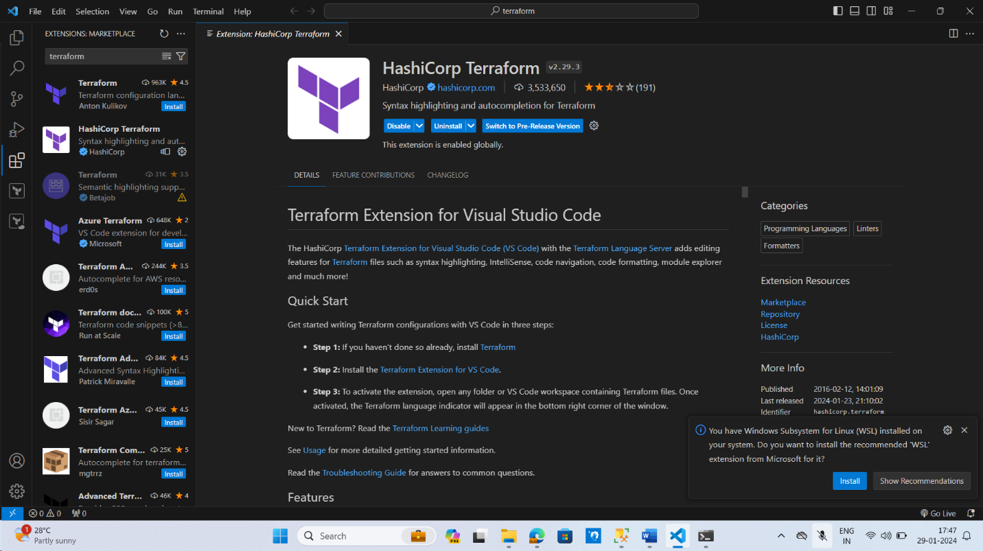

* **Create a New Project Folder**
  + Create a new folder on your computer where you will store your Terraform files.
  + Open this folder in Visual Studio Code (File > Open Folder).
* **Initialize a New Terraform Configuration File**
  + Create a new file in the folder with the **.tf** extension, for example, **main.tf**.
  + Write a simple Terraform configuration or leave it blank for now.

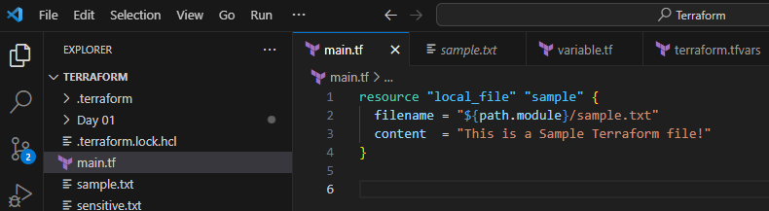

#### **Lab 2: Basic Local File Operation**

* **Define a Local File Resource**
  + In **main.tf**, start by defining a resource to create a local file. For example:
* **Initialize Terraform**
  + Open the terminal in VS Code (Terminal > New Terminal).
  + Run **terraform init** to initialize the Terraform project. This command sets up Terraform to run your configuration.
* **Apply Configuration**
  + Run **terraform apply** to apply your configuration.
  + Confirm the action in the terminal when prompted.
  + This step will create a file named **sample.txt** with the content "Hello, Terraform!" in your project directory.

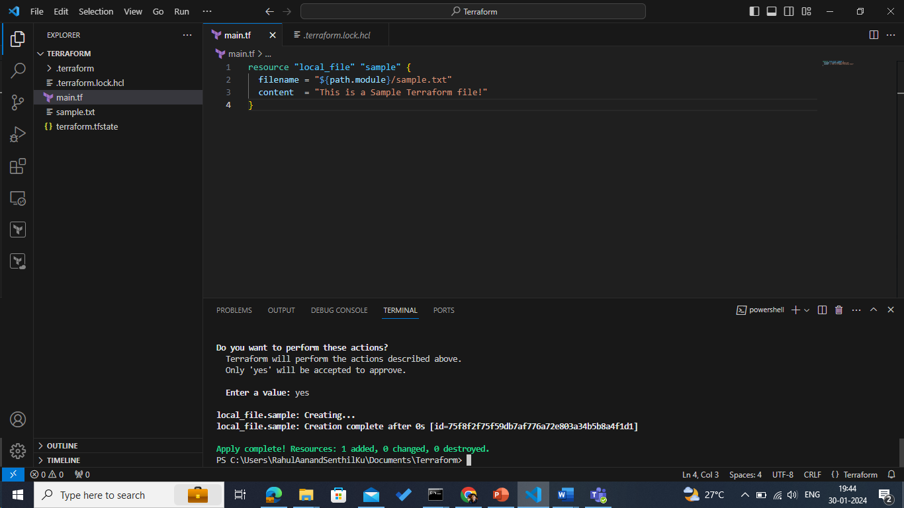

#### **Lab 3: Handling Sensitive File Operations**

* **Create a Sensitive File Resource**
  + Now, let us handle a sensitive file operation. For example, you might want to create a file that contains sensitive information.
  + In **main.tf**, add a new resource block:
* **Define Variables**
  + Create a new file named **variables.tf** and define a variable for the sensitive content:
* **Add Sensitive Content**
  + Create a **terraform.tfvars** file to store the value of the sensitive content.
  + Add your sensitive content in **terraform.tfvars**, like:
* **Re-run Terraform Apply**
  + Run **terraform apply** again in your terminal.
  + Confirm the action when prompted.
  + Terraform will now create another file named **sensitive.txt** with the sensitive content, and it will treat the content as sensitive in its output.
* **Verify the Files**
  + Check your project directory. You should see two new files: **sample.txt** and **sensitive.txt**, each with the specified content.

